Obesity Level Prediction Using Machine Learning and Lifestyle Factors

Caroline Iheanacho and Primrose Mncube

A Report Submitted in Partial Fulfilment
of the requirements for the
Degree of
BSc in Computing in IT (4th year)



May 2026

Supervisor:
Dr. Muhammad Iqbal

Abstract:
This research analyses the machine learning classification models used to predict obesity levels based on demographic, behavioural, and lifestyle factors. The study addresses the basic methodological issues in multiclass classification, feature selection, and model optimisation, as well as giving important insights into the factors that influence obesity classification.

The study uses the Obesity dataset and the CRISP-DM framework to guide the data analytics process, which includes data understanding, preparation, modelling, and evaluation. Three classification algorithms were used, decision tree, K-nearest neighbours (KNN), and Random Forest. These models were selected to represent different types of learning approaches, including tree-based, distance-based, and ensemble methods. To improve model performance, hyperparameter tuning was done using GridSearchCV, with weighted F1-score used as the key evaluation metric due to the problem's multiclass nature.

The research makes three main contributions. First, it evaluates the comparative performance of different classification algorithms in predicting obesity levels and identifies the most effective model for this task. Second, it examines the impact of hyperparameter tuning on model performance, demonstrating how optimisation improves classification accuracy and generalisation. Third, the study develops a prototype Obesity Risk Prediction Tool, illustrating how predictive models can be applied in a practical decision-support context for health awareness.

The findings give evidence for how suitable machine learning models for obesity classification, highlight the importance of model tuning, and highlight the potential of data-driven approaches in supporting the early detection of obesity risks. These findings help improve both academic understanding and practical applications in health-related predictive analytics.

Introduction
Obesity is a serious global public health concern, with growing rates in both developed and developing countries. It is associated with many different kinds of chronic health issues, including cardiovascular disease, diabetes, and reduced life expectancy. Obesity's complexity comes from the interaction of multiple factors, including demographic factors, eating habits, physical activity, and behavioural patterns. This complexity makes obesity an important area for data-driven analysis and predictive modelling.(World Health Organization, 2025)

Recent advances in data analytics and machine learning have enabled researchers to analyse large datasets and identify patterns that would have been difficult to identify using standard statistical methods. Decision Trees, K-Nearest Neighbours (KNN), and Random Forest are examples of machine learning classification algorithms that have been widely used in healthcare prediction applications due to the ability to handle non-linear relationships and complex feature interactions. These methods provide an opportunity to improve obesity classification and help in the early identification of those at risk. (Dritsas and Trigka, 2025)

The Obesity dataset used in this study contains demographic, behavioural, and lifestyle variables, allowing for a structured analysis of the factors that influence obesity levels. This research uses a machine learning approach to explore how these variables contribute to obesity classification and to analyse the effectiveness of different algorithms in predicting obesity categories. (archive.ics.uci.edu, 2019)

Problem statement

Obesity is an increasing global public health concern, associated with an increased risk of chronic diseases like diabetes, hypertension, and cardiovascular disease. Obesity is caused by a complex combination of demographics, eating habits, physical activity, family history, and lifestyle choices.

Traditional methods often focus on treating obesity after it has developed, rather than addressing risk factors early on. Predictive analytics and machine learning may help in early identification by analysing patterns in health and lifestyle data to predict obesity levels.

This project seeks to address this problem by developing a predictive model that classifies individuals into obesity categories using demographic and behavioural data.

Data Understanding

The dataset used in this project is the Obesity Dataset (ObesityDataSet_raw_and_data_sinthetic), which contains information related to individuals’ demographic characteristics, UCI (archive.ics.uci.edu, 2019)
The data understanding phase focuses on exploring and getting familiar with the dataset before building any machine learning models. At this stage, the goal is to understand what kind of data we are working with, identify patterns, and check for any issues that might affect the results later on.
The dataset used in this project contains information about individuals such as their age, gender, height, weight, eating habits, physical activity, and lifestyle choices.
From an initial inspection, it is clear that the dataset includes a mix of numerical values (such as age, height, and weight) and categorical variables (such as gender, smoking habits, and transportation type). The target variable, NObeyesdad, represents different obesity categories, which means this is a classification problem.
Understanding these variables is important because it helps identify which features may influence obesity levels and ensures the data is suitable for building predictive models.
Data Description
The dataset consists of several groups of variables:
- Demographic variables: Gender, Age
- Physical attributes: Height, Weight
- Eating habits:
  - FAVC (frequent consumption of high-calorie food)
  - FCVC (frequency of vegetable consumption)
  - NCP (number of main meals)
  - CAEC (consumption of food between meals)
  - CH2O (water consumption)
  - CALC (alcohol consumption)
- Lifestyle behaviours:
  - FAF (physical activity frequency)
  - TUE (technology usage time)
  - SMOKE (smoking habits)
  - SCC (calorie consumption monitoring)
- Family background:
  - family_history_with_overweight
- Transportation:
  - MTRANS
- Target variable:
  - NObeyesdad (obesity level category)
Target Variable Analysis
The target variable NObeyesdad represents different categories of obesity, making this a multi-class classification problem. We used a count plot to examine the different obesity categories
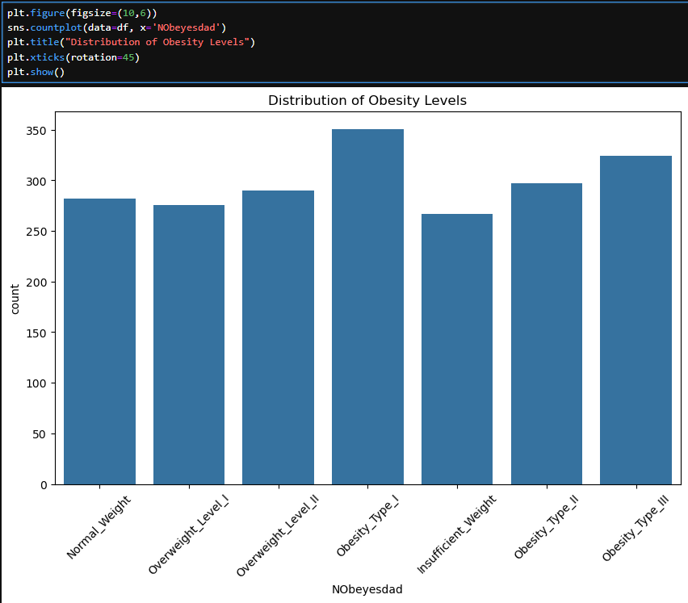

Key Observations:
The dataset contains multiple obesity classes, including normal weight, overweight, and various obesity types. Some classes appear more than others.
Exploratory Data Analysis
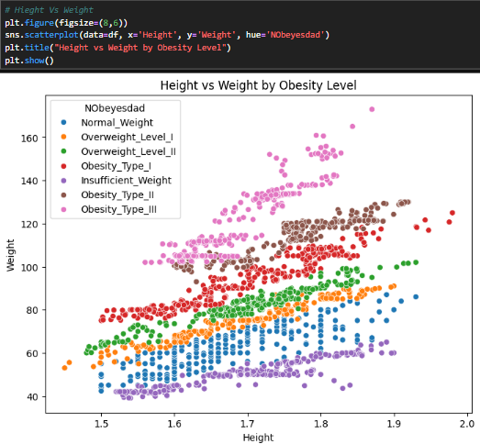
Relationship between height and weight
We used a scatter plot to analyze the relationship between height and weight. From looking at the data is it evident that obesity categories are significantly more influenced by weight than by height. People are more likely to become obese as their weight increases, and this trend is rather constant across the dataset. In contrast, there is less variation in height between the various categories, therefore it is not as important for differentiating between them. Even though taller people tend to weigh more, the shift in the definition of obesity is actually driven by weight gain. Overall, data indicates that while height has a smaller and less obvious effect, weight is one of the most significant characteristics for predicting obesity levels.

References
archive.ics.uci.edu. (2019). UCI Machine Learning Repository. [online] Available at: https://archive.ics.uci.edu/dataset/544/estimation+of+obesity+levels+based+on+eating+habits+and+physical+condition.
‌

